|  |  |  |  |
| --- | --- | --- | --- |
| Description | Current | Change | Recommended |
| Agentia SuperSMA - Pension |  |  |  |
| Investment number one | $50,000 | $50,000 | $0 |
| Investment number one | $20,000 | $20,000 | $0 |
| Investment number two | $60,000 | $60,000 | $0 |
| Agentia SuperSMA - Pension | $130,000 | $130,000 | $0 |
| Total | $130,000 | $130,000 | $0 |

|  |  |
| --- | --- |
| Status | Current |
| Product | Agentia SuperSMA - Pension |
| Balance | $130,000 |
| Investments | Investment number one, Investment number one, Investment number two |
| One-off Fees Subheader |  |
| Ongoing Fees Subheader |  |
| Admin Fee (Floating) | $624.00 (0.48%) |
| Expense Recovery Fee (Flat) | $65.00 |
| ORR Levy | $78.00 (0.06%) |
| Fund Accounting Fee (Flat) | $144.00 |
| Investment Fee | $1,050.00 (0.81%) |
| Subtotal | $1,961.00 |
| Total | $1,961.00 |
| Aggregated Total | $1,961.00 |
| AA Summary |  |

|  |  |  |  |
| --- | --- | --- | --- |
| Status | Current | Risk Profile | Variance |
| Defensive Subheader |  |  |  |
| Cash | 9.23% | 0% | 9.23% |
| Australian Fixed Interest | 0% | 0% | 0% |
| International Fixed Interest | 0% | 0% | 0% |
| Defensive Subtotal | 9.23% | 0% | 9.23% |
| Growth Subheader |  |  |  |
| Australian Equities | 63.85% | 50.00% | 13.85% |
| International Equities | 26.92% | 50.00% | -23.08% |
| Australian Listed Property | 0% | 0% | 0% |
| International Listed Property | 0% | 0% | 0% |
| Direct Property | 0% | 0% | 0% |
| Growth Subtotal | 90.77% | 100.00% | -9.23% |
| Alternative Subheader |  |  |  |
| Alternatives | 0% | 0% | 0% |
| Alternative Subtotal | 0% | 0% | 0% |
| Total | 100.00% | 100.00% | 100.00% |

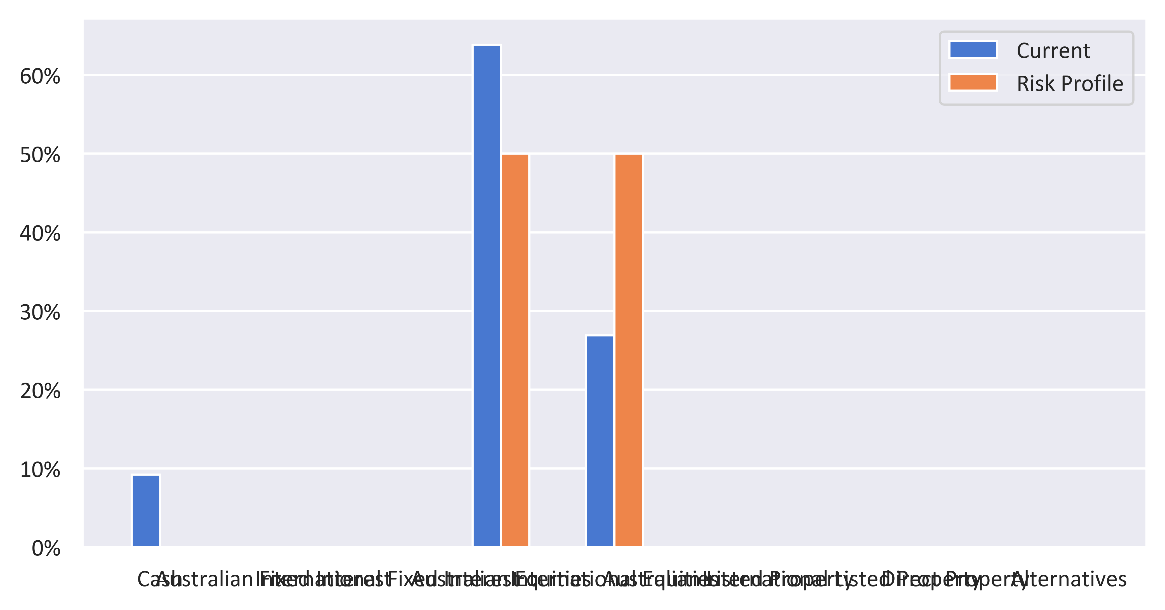

|  |  |  |  |
| --- | --- | --- | --- |
| Status | Recommended | Risk Profile | Variance |
| Defensive Subheader |  |  |  |
| Cash | 0% | 0% | 0% |
| Australian Fixed Interest | 0% | 0% | 0% |
| International Fixed Interest | 0% | 0% | 0% |
| Defensive Subtotal | 0% | 0% | 0% |
| Growth Subheader |  |  |  |
| Australian Equities | 0% | 50.00% | -50.00% |
| International Equities | 0% | 50.00% | -50.00% |
| Australian Listed Property | 0% | 0% | 0% |
| International Listed Property | 0% | 0% | 0% |
| Direct Property | 0% | 0% | 0% |
| Growth Subtotal | 0% | 100.00% | -100.00% |
| Alternative Subheader |  |  |  |
| Alternatives | 0% | 0% | 0% |
| Alternative Subtotal | 0% | 0% | 0% |
| Total | 100.00% | 100.00% | 100.00% |

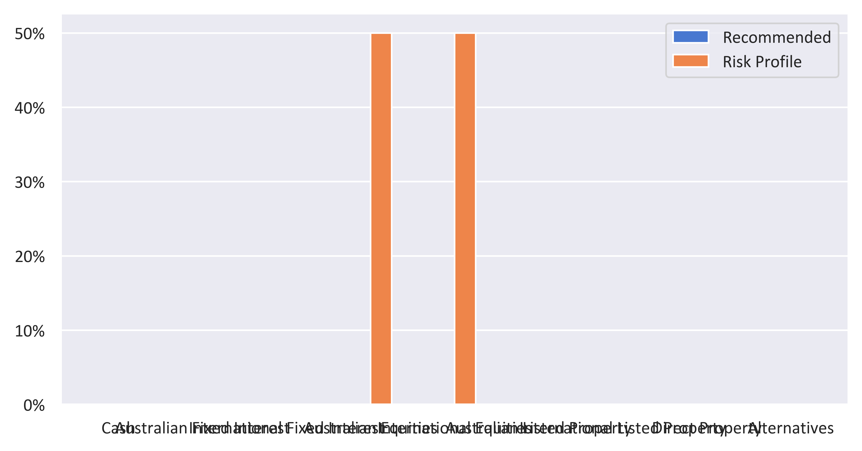

|  |  |  |  |  |
| --- | --- | --- | --- | --- |
| Status | Current | Risk Profile | Recommended | Variance |
| Defensive Subheader |  |  |  |  |
| Cash | 9.23% | 0% | 0% | 0% |
| Australian Fixed Interest | 0% | 0% | 0% | 0% |
| International Fixed Interest | 0% | 0% | 0% | 0% |
| Defensive Subtotal | 9.23% | 0% | 0% | 0% |
| Growth Subheader |  |  |  |  |
| Australian Equities | 63.85% | 50.00% | 0% | -50.00% |
| International Equities | 26.92% | 50.00% | 0% | -50.00% |
| Australian Listed Property | 0% | 0% | 0% | 0% |
| International Listed Property | 0% | 0% | 0% | 0% |
| Direct Property | 0% | 0% | 0% | 0% |
| Growth Subtotal | 90.77% | 100.00% | 0% | -100.00% |
| Alternative Subheader |  |  |  |  |
| Alternatives | 0% | 0% | 0% | 0% |
| Alternative Subtotal | 0% | 0% | 0% | 0% |
| Total | 100.00% | 100.00% | 100.00% | 0.00% |

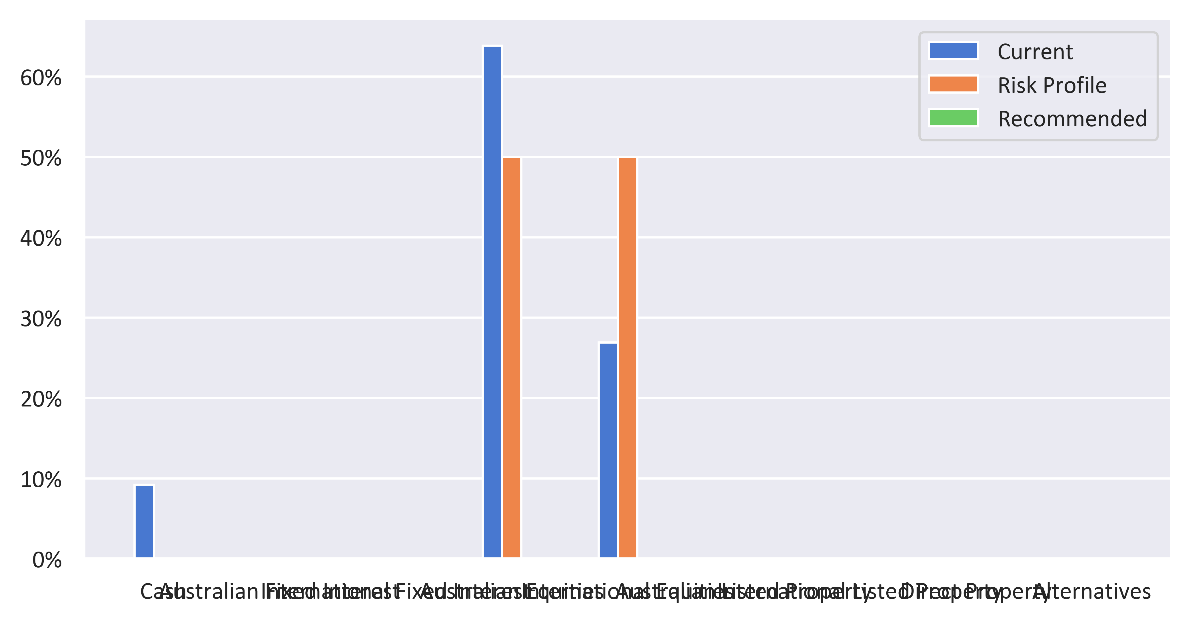

|  |  |  |  |
| --- | --- | --- | --- |
| Status | Current | Recommended | Variance |
| Defensive Subheader |  |  |  |
| Cash | 9.23% | 0% | -9.23% |
| Australian Fixed Interest | 0% | 0% | 0% |
| International Fixed Interest | 0% | 0% | 0% |
| Defensive Subtotal | 9.23% | 0% | -9.23% |
| Growth Subheader |  |  |  |
| Australian Equities | 63.85% | 0% | -63.85% |
| International Equities | 26.92% | 0% | -26.92% |
| Australian Listed Property | 0% | 0% | 0% |
| International Listed Property | 0% | 0% | 0% |
| Direct Property | 0% | 0% | 0% |
| Growth Subtotal | 90.77% | 0% | -90.77% |
| Alternative Subheader |  |  |  |
| Alternatives | 0% | 0% | 0% |
| Alternative Subtotal | 0% | 0% | 0% |
| Total | 100.00% | 100.00% | 100.00% |

